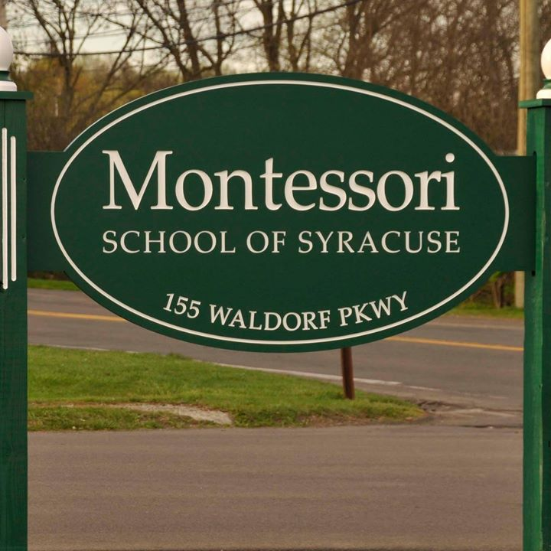

MINIMUM CAPACITY :-

The Minumum intake capacity

of students is between 400-620

children

LIBRARY :-

The Libarary is Available.

CANTEEN:-

The Canteen Facility is Available.

BOARDING :-

No availablility of boarding.

SPORTS :-

There are different categories

sports available.

Girls Volleyball

Boys Volleyball

Football

|  |  |  |
| --- | --- | --- |
| MONTESSORI SCHOOL OF SYRACUSE SYRACUSE - SCHOOL |  |  |
|  |  |  |
| School Detail :- The Montessori School of Syracuse sits on an eight-acre campus near the intersection of Tecumseh and Nottingham roads in DeWitt. Our students also enjoy the use of the Montessori Land Laboratory, a 50-acre wooded property with a pond and buildings in Pompey.  In addition to the traditional school subjects such as mathematics, science, history and language arts (reading, writing and grammar), we offer a broad range of subjects designed to enrich our students’ personal and academic development. These subjects include French, music history, geography, geometry, and Great Books. |  |
|